Midterm

Spring 2019
CSE 5339/7339 Computer System Security
Dr. Estes

Instructions: No resources are allowed. This means no internet, no notes, and no information stored on your computer. Remove the password from the file before uploading. The exam may be printed, filled out by hand, and then scanned back in, or completed and uploaded to Canvas. Please keep all answers as concise as possible while still conveying all necessary concepts. Please show all necessary work. An extra page is provided in the event that you need more room. You will be given 1 hour 30 minutes to complete the exam. You should begin trying to upload at least 5 minutes prior to ensure you are able to upload.
- 10 points: Using the following word bank, select fill in the blank with the term most directly related to the concepts below:

Authorization | Authentication | Symmetric Key System
Cipher Text | Kerchoffs’ Principle | Plain Text
Public Key System

Symmetric Key System: Can be used with a Message Authentication Code to provide Integrity to a message.

Cipher Text: The scrambled version of the message in an encryption system.

Authorization: The process of giving someone permission to do or have something. Limited by such technologies as firewalls, Intrusion Detection Systems, and Multilevel Security Systems

Kerchoffs’ Principle: The idea that a cryptosystem should be secure even if everything about the system, except the key, is public knowledge.

Public Key System: Provides the ability to add a secure ‘digital signature’ to a message.

Plain Text: The original input into an encryption system before modification to obfuscate the message.

Authentication: The process of determining whether someone or something is, in fact, who or what it is declared to be.

- 10 points: Briefly describe each of the three components of the C.I.A. Triad including what each is directed at protecting:

C: Confidentiality
Is the data properly protected from the public eye? Are people that aren’t supposed to be able to see the data still able to access the data?

I: Integrity
Is the data properly stored? Are there any errors with the stored data, and are they detected?

A: Availability
Are the people that are supposed to be able to view the data still able to view the data? Is it locked down too tight for anyone, even with the right credentials, able to view the data, or can people with the right credentials still able to see the data while maintaining confidentiality of the data?

- 10 points: A Feistel Cipher is a general format for one possible method of performing a block cipher. Describe the basic flow of a Feistel cipher being sure to include what primary mathematical operator is required to meet this format. (Be able to describe. This can be a flow chart, series of algorithms, or textual description.).

A Feistel Cipher generally involves splitting the data into two equally sized halves (let’s call them L and R for now). Then, some operation (such as an XOR) will be applied to one of the halves (for example, after an XOR we now have L and R₁), and then L₁ will be determined with some combination involving R₁. Each subsequent R_{i} and L_{i} will depend on the previous iteration (i.e., R_{i} = L_{i} XOR R_{i-1}).

- 5 points: Compare and contrast Symmetric Key Systems vs. Public Key Systems:
Symmetric key systems are all centered around one key that is used for both encryption and decryption of all data. Public Key systems involve each user having their own public and private key, and all data that any user sees must be encrypted with their set of public and private keys. Using an Alice and Bob example, both Alice and Bob would encrypt and decrypt their messages with the same key in a symmetric key system. In a public key system, Bob would send Alice messages encrypted with Alice’s public key, and she would decrypt them with her (Alice’s) private key. Symmetric key systems are harder to recover from if breached, however, because everyone must securely receive the new key once again, while in a public key system a new public/private key pair must be generated for whatever individual(s) was/were compromised and then the new public keys must be spread to each user.

- 5 points: What is the name given to the primary method of sharing a Symmetric Key (not used for encrypting or signing) based on a discrete log problem where each user must find the exponent k given g, p, and gk mod p, with each user selecting their own private value for k. Diffie-Hellman

- 5 points: Solve the following modular arithmetic problems:

11 mod 8 = 3

11-1 mod 7 = 0
-3 mod 8 = -3

49 mod 5 = 4

- 5 points: What are the three primary components of Public Key Infrastructure? Briefly describe one of the primary PKI Trust Models.
I’m pretty sure this is wrong but I can’t think of anything else… is it:
Identification
Authentication
Authorization

Where Identification is presenting yourself as a valid user
Authentication is proving yourself to be who you say you are
and Authorization is what you have access to once your identity is proven

- 10 points: Using a Caesar Cipher with a key of 5, solve the following substitution cipher:

ABCDEFGHIJKLMNOPQRSTUVWXYZ
VWXYZABCDEFGHIJKLMNOPQRSTU
Ymj fsxbjw yt szrgjw knaj nx Inkknj-Mjqqrfs.
The answer to number five is Diffie-Hellman.

- 10 points: During the first round of a DES encryption cycle, the 32-bits of R0 are found to be: R0 = 0000 0000 0000 0000 0010 1010 0110 0100
This is ran through the expansion permutation box [E] below to generate 48-bit E(R0) Find E(R0) .

Expansion Permutation (E)
32 | 1 | 2 | 3 | 4 | 5
4 | 5 | 6 | 7 | 8 | 9
8 | 9 | 10 | 11 | 12 | 13
12 | 13 | 14 | 15 | 16 | 17
16 | 17 | 18 | 19 | 20 | 21
20 | 21 | 22 | 23 | 24 | 25
24 | 25 | 26 | 27 | 28 | 29
28 | 29 | 30 | 31 | 32 | 1

E(R0) = 000000 000000 000000 000000 000101 010100 001100 001000

- 10 points: For this same iteration of DES, K1 is found to be:

K1 = 010011110110110100110101001010101111110110101011

Using the solution, E(R0), from the previous question, and K1 find the 48-bit input for the S-Boxes, (B) .

B = K₁ XOR E(R₀)
= 0100 1111 0110 1101 0011 0101 0010 1010 1111 1101 1010 1011
XOR 0000 0000 0000 0000 0000 0000 0001 0101 0100 0011 0000 1000
B = 0100 1111 0110 1101 0011 0101 0011 1111 1011 1110 1010 0011

- 10 points: Using the solution, B, from the previous question, determine the proper input and solution to S-Box, S1 below:

B1 = 010011 110110 110100 110101 001111 111011 111010 100011
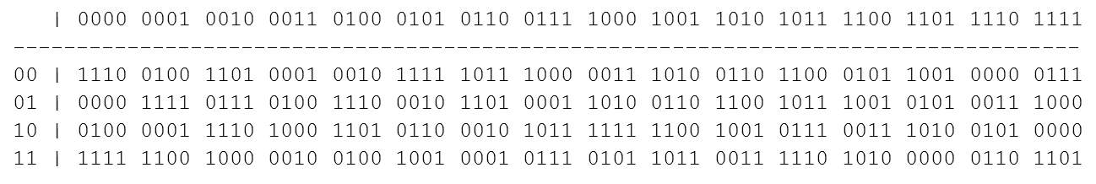

S1 Output = 0100 0001 0100 1001 0111 1110 0011 1000
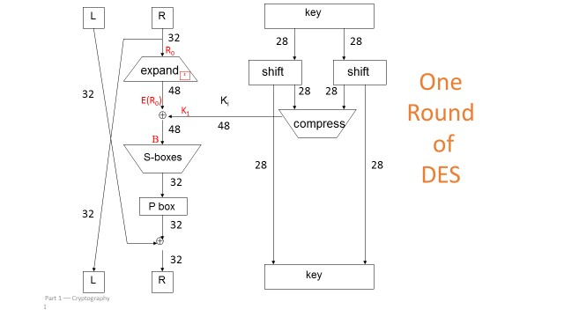

12) 10 points: Given the example below, generate a unique key pair by selecting p, q, N, e, and d (DO NOT USE ANY OF THE VALUES LISTED BELOW FOR p or q)
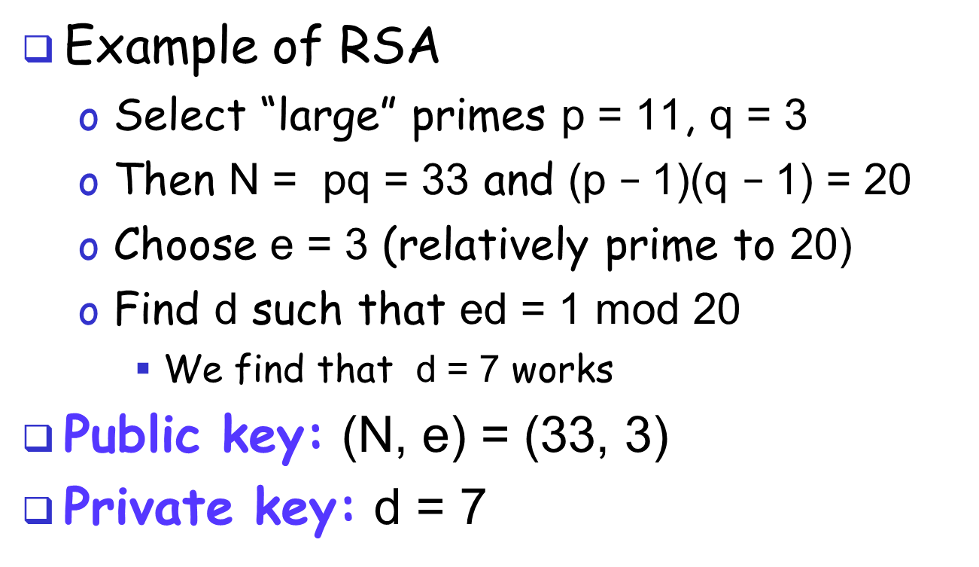

P = 17, Q = 5
N = 85
(p-1)(q-1) = (16)(4) = 64
E = 13
D = 5
13 x 5 = 65 = 1 mod 64

p = 17 , q = 5 , N = 85 , e = 13 , d = 5

Extra Work (to be turned in with Exam).

